EGYPT
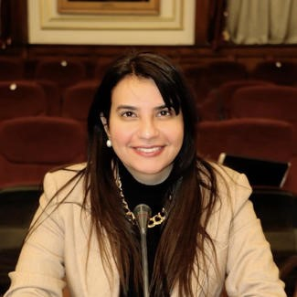 |  | Sahar Albazar  MP, Deputy Chair, Committee for Foreign Relations, Egypt  Hon. Sahar Albazar has been a Member of Parliament since 2020 and is the Deputy Chair of the Foreign Affairs Committee. She has also been the President of the IPU Forum of Young Parliamentarians since 2021.  Hon. Albazar has extensive experience in development and civil society in Egypt, Somalia and Kenya addressing women’s empowerment, education and youth employment, and health care. She has concrete experience in proposing and communicating policy recommendations to diverse audiences ranging from clients to key stakeholders and high-level government officials.  Prior to her role in parliament, Hon. Albazar was Minister’s Advisor to the Ministry of Social Solidarity where she led the CSR and Public Private Partnerships unit at the Ministry from 2016 to 2020. Hon. Albazar also served as a Social Protection and Impact Assessment Consultant at the World Bank in Egypt from 2016 to 2017.  She holds a Bachelor’s degree in Business Administration from Ain Shams University in Cairo and a Masters in Public Administration (MPA) degree from Harvard University.
GUINEA
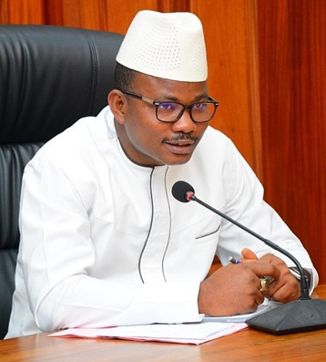 |  | Dansa Kourouma  MP, Speaker of Parliament, Republic of Guinea  Dr. Dansa Kourouma is the Speaker of Parliament representing electoral reforms and governance in the Parliament of Republic of Guinea. Kourouma holds key positions in various organizations, including President of the National Council of Guinean Civil Society Organizations (CNOSCG), Vice-President of the West African Electoral Monitoring Network, and President of the Citizen Election Monitoring Platform in Guinea (Regard du peuple - RdP).  His educational journey includes studying in Faranah and pursuing a medical degree at the University Gamal Abdel Nasser in Conakry. He also obtained a license in program and project management and a degree in medical expertise in legal compensation for bodily harm.  Kourouma has an extensive professional background, serving as the Executive Director of the Observatory for Governance and Accountability (OCGR) and interim President of the Civil Society Forum of ECOWAS. He has been actively involved in electoral monitoring in West Africa and was the Coordinator General of the National Election Monitoring Platform (Regard du Peuple) during the 2020 elections. He has played significant roles in electoral reforms, including serving as a member of the national expert group for the review of the electoral code and leading the committee for implementing Kindia's recommendations on electoral reforms.
ITALY
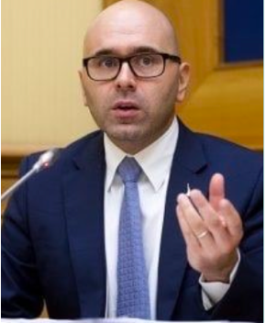 | Giulio CENTEMERO  MP, Italy, President of the 2nd Standing Committee on Socio-economic and environmental affairs, Parliamentary Assembly for the Mediterranean (PAM)  Hon. Giulio Centemero is a member of the Chamber of Deputies at the VI Finance Committee, coordinator of the financial markets unit of the Economics Department of the Lega and Treasurer of the party since 2014. He is a member of the Italian delegation to the Parliamentary Assembly of the Mediterranean (PAM).  He is a Chartered Accountant and Statutory Auditor, with a degree in economics and commerce from the University of Bergamo and an executive Master in  PA management from SDA Bocconi as well as a graduate certificate in Project management from Boston University.  Hon. Centemero trained professionally in tax M&A and at the same time consolidated his political experience in the European parliament together  with Matteo Salvini. He is also co-chairman of the economic panel of the Parliamentary Assembly of the Mediterranean, a member of the executive board of the International Parliamentary Network for Education and president of the parliamentary intergroup of Friendship Italy - Armenia.  He has published interviews and articles in generalist and financial sector magazines and channels. His greatest interest lies in fintech and alternative capital markets.
JAMAICA
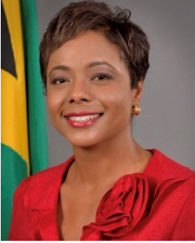 |  | Hon. Marlene MALAHOO FORTE  QC, MP, JP, Minister of Legal and Constitutional Affairs, Jamaica; Vice-Chair of the Parliamentary Network  Hon. Marlene Malahoo Forte was appointed Minister of Legal and Constitutional Affairs in January 2022. She is a Member of Parliament who has served in both Houses of Parliament of Jamaica. She previously served as Opposition Senator Senate Spokesperson on Foreign Affairs and Foreign Trade (2012 - 2014) and Shadow Minister of Health (2015 - 2016). She is the former Attorney General of Jamaica where she served from 2016 to 2022. Hon. Forte holds a Master of Public Administration (MPA) Degree and Diploma in Public Policy and Management from Harvard University, a Master of Law (LLM) Degree in Commercial Laws with further specialty in Financial and Regulatory Laws (Commonwealth Scholar) from King’s College London, a Bachelor of Laws Degree (LLB) (Hons) from the University of the West Indies in Barbados, a Certificate of Legal Education from the Norman Manley Law School (Jamaica) and Diploma in International Arbitration and is a Fellow of the Chartered Institute of Arbitrators in London. She is also a Yale World Fellow and alum of Yale University.
MOROCCO
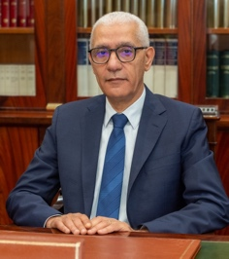 |  | Rachid Talbi Alami  President of the House of Representatives of Morocco  Hon. Rachid Talbi El Alami was elected Speaker of Parliament of the Moroccan Chamber of Representatives on October 9, 2021. Previously he was the Minister of Youth and Sports from April 2017 to October 2019, and the Speaker of Parliament from 2014 to 2016. Hon. Alami also held the position of Minister Delegate to the Prime Minister in charge of Economic and Public Affairs from June 2004 to October 2007, and was the Minister of Industry, Trade and Communications from November 2002 to June 2004. He holds a Ph.D. in Management and Finance from New York University, USA.
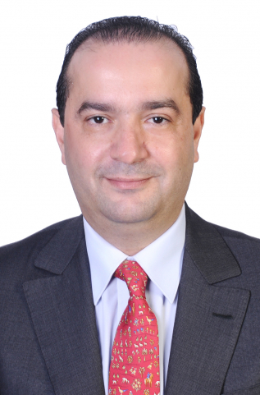 |  | Mohamed Chaouki  MP, President, Committee for Finance and Economic Development, Morocco  Hon. Mohamed Chaouki is a deputy in the House of Representatives of Morocco. He belongs to the National Rally of Independents, currently serving as the Chairperson of the Finance and Economic Development Committee.  In November 2022, Hon. Chaouki has received the delegation of International Monetary Fund (IMF). As part of Morocco's annual consultations with the IMF, Hon. Chaouki engaged in discussions with the IMF's Chief of Mission, Roberto Cardarelli, and other delegation members. During this meeting, he provided a comprehensive overview of the Finance and Economic Development Committee's recent work and its impact on Morocco's economic landscape. In addition to his role in promoting economic reforms, Rep. Chaouki discussed the significance of the 2023 Finance Bill, which includes critical social and tax reforms. He highlighted the government's commitment to maintaining macroeconomic balances while implementing essential changes.  Hon. Chaouki has studied business administration at Al Akhawayn University and is an alumnus of the School of Business Administration.
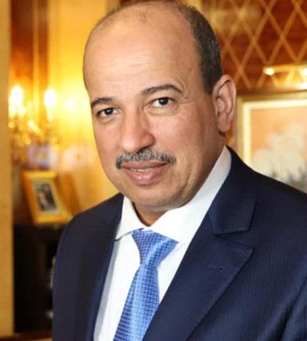 |  | Enaam Mayara  President of the House of Councillors of Morocco  Senator Enaam Mayara was elected President of the House of Councilors of Morocco on October 9, 2021. Parallel to his role in parliament, he is President of the Parliamentary Assembly of the Mediterranean (PAM) from 2023 to 2024, and Secretary General of the General Union of Moroccan Workers (UGTM). Previously he was elected as Deputy of the House of Councilors in 2019 and 2015, he was the Regional Secretary of the National Federation of Employees and agents of the local authorities of the province of Laâyoune in 1996, and the Head of department of the green zones at the Urban Community from 1991 to 2009. He is an engineer laureate of the Agronomic and Veterinary Institute (AVI).
Neila Tazi
Chair, Committee for Foreign Affairs, National Defence, and Moroccans Foreign Residents
Senator Neila Tazi has been a Senator in the Moroccan House of Counselors since 2015, where she was the first woman Vice-President of the Senate from 2016 to 2018, and the first to chair plenary sessions. She was born in Washington DC where her father was an Executive Director at the World Bank in the late 1960s, giving her a life-long connection to the World Bank. She is the Chair of the Moroccan Chapter of the Parliamentary Network (PN) and frequently plays an active role in PN global and regional activities. Ms. Tazi was elected as President of the Federation of Cultural and Creative Industries in February 2019. In 1998 she founded the Essaouira Gnaoua and World Music Festival.
ROMANIA
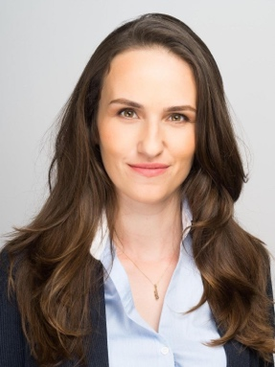 |  | Oana-Silva Toiu  Chair, Youth and Sports Committee, Romania  Ms. Toiu is a former state secretary in Romania’s Ministry of Labour, applies her passion for social innovation to search for solutions irrespective of whether they come from policy, field work or business. She is the founder and general manager of Social Innovation Solutions, which offers training and consultancy in social innovation and entrepreneurship. Annually they run in partnership with Global Shapers two start-up ideas challenges, Social Impact Award and Future Makers, engaging in trainings more than 1400 young people across Romania and connecting the best ideas with a global network of solutions.  She is also a teacher and a Board member of The Entrepreneurship Academy, where students work in teams, learning about business by running real businesses under the guidance of a “team coach”.  Oana has been invited to speak at the “Future of Europe” at Harvard and at the European Commission conferences, has been featured in 101 Romanians that have an impact on the country by Foreign Policy, as one of the 6 young leaders who are improving the state of the world by the World Economic Forum agenda and is an AIESEC alumna and a German Marshall Fund Memorial Fellow. Oana is part of the 2012 generation of the Aspen Young Leaders Program.
SOUTH AFRICA
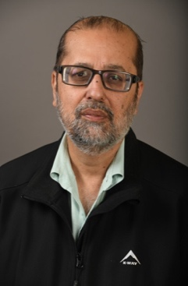 |  | Yunus Carrim  Chairperson, NCOP Select Committee on Finance, South Africa  Mr Carrim holds a Master's in Sociology from the University of Warwick in England and an International Diploma in Journalism from Darlington College of Technology in England.  He was a member of the Executive Committee of the Natal Indian Congress, a member of the Executive Council of the United Democratic Front in Pietermaritzburg, and a Secretary of the Pietermaritzburg Combined Ratepayers and Residents Association from 1986 to 1990. He was a Senior Lecturer in Sociology at the University of Kwa-Zulu Natal.  Mr. Carrim also served as Deputy Minister of Cooperative Governance and Traditional Affairs (2009 to 2013) and Minister of Communications (2013 to 2014). Mr Carrim was Chairperson of the Standing Committee on Finance during the Fifth Parliament (2014-2019).
TANZANIA
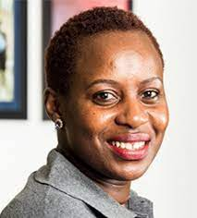 |  | Neema LUGANGIRA  MP, Committee for Foreign Affairs, Defence & Security, Tanzania  Hon. Neema Lugangira is the Member of Parliament representing NGOs in the Parliament of Tanzania. She is Chair of the Parliamentary Caucus on Food Safety and a member of the Committee on HIV, TB and Drugs, as well as the Committee on Social Services and Community Development.  She is a champion of education with Haki Elimu, the national education coalition in Tanzania, and a member of the International Parliamentary Network for Education. She is also a National Food Systems Champion for the Ministry of Agriculture, and a National Non-Communicable Diseases Champion for the Ministry of Health.  She has significant experience in leading national and international development projects, including overseeing the administration of agricultural and social-economic programs and initiatives across Tanzania. She is also the founder of the Agri Thamani Foundation, which seeks to end malnutrition through education, agricultural sector planning and policy advocacy.
TONGA
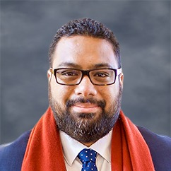 |  | Fatafehi Fakafanua  MP, Speaker of Parliament, Kingdom of Tonga  Fakafanua, known before ascending to his title as Fatafehi Kinikinilau Lolomana‘ia Fakafanua is a Tongan politician, Lord of the Realm and former Speaker of the Tongan Legislative Assembly. He is the 8th Fakafanua.  He was bestowed with the title Fakafanua, one of the thirty-three hereditary titles of the Tongan nobility, on 24 April 2006. The title is attached to the estates of Ma'ufanga (on Tongatapu), Nga'akau (on Vava'u) and Faleloa (on Ha'apai), and enables its holder to be elected to the Legislative Assembly as a Representative of the Nobility. During the 2008 by-election he was elected as a representative for Ha'apai, the youngest member ever of the Tongan Parliament. He was re-elected in the November 2010 general election. On 19 July 2012 he was elected Speaker of the Tongan Legislative Assembly following Lord Lasike's removal from office. He was Tonga's youngest ever Speaker.  In 2008, King George Tupou V appointed Fakafanua Commander of the Order of Queen Salote Tupou III.
INTERNATIONAL FINANCE CORPORATION
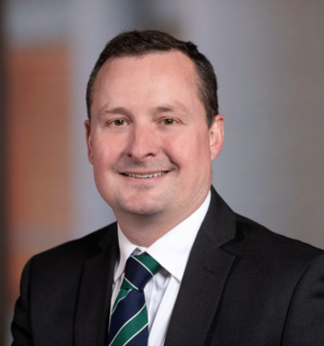 |  |  | Jamie Fergusson  Director, Climate Business Director, International Finance Corporation (IFC)  Jamie is responsible for IFC’s climate strategy and policies, and delivery on its ambitious targets to make all investments Paris Aligned and 40% of its investment climate positive. Jamie joined IFC in 2005 and has led and contributed to a range of innovation and new business growth across IFCs investment, advisory and support operations. Jamie’s direct transaction experience includes corporate and project debt, equity and mezzanine investments in hydro, wind, solar PV, solar CSP, geothermal and biomass in Latin America, Africa, South and East Asia and the Middle East. As Global Director for Strategic Market and Business Development, Jamie led a corporation-wide change process to build IFC’s long-term investment pipeline creation practice across all industries and regions. Leading the creation of new teams, processes and products, Jamie helped to build a $34bn 5-year pipeline and grow annual conversions of that pipeline to $4.4bn in investment commitments.  Prior to his career at IFC, Jamie co-founded Credo, a boutique strategic consultancy in London, UK which is now its 20th year of operation. Jamie began his career producing wildlife documentaries for the likes of BBC, Discovery and National Geographic, filming throughout Sub-Saharan Africa.  Jamie has a BA and MA in Zoology from Cambridge University, UK, and both a Master’s in Environmental Economics & Policy and an MBA from Yale University, USA.
INTERNATIONAL MONETARY FUND
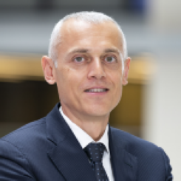 |  | Fabio Natalucci  Deputy-Director, Monetary and Capital Markets Department, IMF  Fabio Natalucci is a Deputy Director of the Monetary and Capital Markets Department with responsibility for the IMF’s global financial markets monitoring and systemic risk assessment functions. He is responsible for the Global Financial Stability Report that gives the IMF’s assessment of global financial stability risks. Prior to joining the IMF, Fabio was a Senior Associate Director in the Division of Monetary Affairs at the Federal Reserve Board, where he conducted research and current analysis on the relationship between monetary policy, financial regulatory policy, and financial stability. Between October 2016 and June 2017, Mr. Natalucci was Deputy Assistant Secretary for International Financial Stability and Regulation at the U.S. Department of Treasury. His responsibilities included leading U.S. engagement on financial regulatory cooperation in the G-20, representing the U.S. Treasury at the Financial Stability Board, coordinating between domestic and international post-crisis regulatory reforms, and monitoring developments and vulnerabilities in global financial markets.
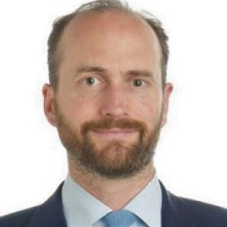 |  | Tommaso Mancini-Griffoli  Division Chief, Payments, Currencies, & Infrastructure Division, Monetary and Capital Markets Department, IMF  Tommaso Mancini-Griffoli is a Division Chief in the Monetary and Capital Markets Department at the International Monetary Fund (IMF), focused on monetary policy, central banking, and fintech. He has advised country authorities and published on issues related to unconventional monetary policies, monetary policy and financial stability, spillovers, exchange rate regimes and interventions, modelling and forecasting, evolving monetary policy frameworks, and fintech. Prior to joining the IMF, Mr. Mancini-Griffoli was a senior economist in the Research and Monetary Policy Division of the Swiss National Bank, where he advised the Board on quarterly monetary policy decisions. Mr. Mancini-Griffoli spent prior years in the private sector, at Goldman Sachs, the Boston Consulting Group, and technology startups in the Silicon Valley.
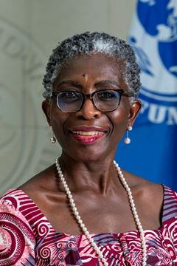 |  | Antoinette Sayeh  Deputy Managing Director, IMF  Before assuming her current role at the IMF, Ms. Sayeh was a Distinguished Visiting Fellow at the Center for Global Development (CGD) and Co‐Chair for the 19th Replenishment of the International Development Association (IDA19), the World Bank’s Fund for the poorest. She previously oversaw and significantly enhanced the IMF’s engagement with its sub‐Saharan African members as Director of the African Department between July 2008 and August 2016. She served as Minister of Finance in post-conflict Liberia (January 2006 through June 2008), where she led the country through the clearance of its long‐standing multilateral debt arrears. Ms. Sayeh graduated with a bachelor’s degree with honors in economics from Swarthmore College and a PhD in International Economic Relations from the Fletcher School at Tufts University.
WORLD BANK
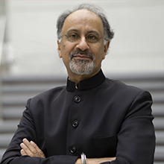 |  | Indermit Gill  Chief Economist and Senior Vice President for Development Economics, World Bank  Indermit Gill is Chief Economist of the World Bank and Senior Vice President for Development Economics.  Before starting this position on September 1, 2022, Gill served as the World Bank’s Vice President for Equitable Growth, Finance, and Institutions, where he helped shape the Bank’s response to the extraordinary series of shocks that have hit developing economies since 2020. Between 2016 and 2021, he was a professor of public policy at Duke University and non-resident senior fellow at the Brookings Institution’s Global Economy and Development program.  Gill led the World Bank's influential 2009 World Development Report on economic geography. His work includes introducing the concept of the “middle-income trap” to describe how countries stagnate after reaching a certain level of income. He has published extensively on key policy issues facing developing countries—among other things, sovereign debt vulnerabilities, green growth and natural-resource wealth, labor markets, and poverty and inequality.  Gill has also taught at Georgetown University and the University of Chicago. He holds a Ph.D. in economics from the University of Chicago.
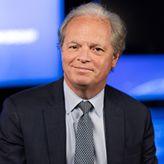 |  | Axel van Trotsenburg  Senior Managing Director of Development Policy and Partnerships, World Bank  Axel Van Trotsenburg directs the World Bank’s core development work captured by the Bank’s Global Practice groups – including equitable growth, finance and institutions; human development; infrastructure; and sustainable development – and ensures its integration into operations, with a special focus on climate change, fragility, human capital, and debt sustainability issues. He currently co-leads the Evolution Roadmap aimed at increasing the scale and impact of the World Bank operations and oversees the Bank’s numerous partnerships including with the UN, international financial institutions (IFIs), and bilateral partners. Prior to this, Mr. van Trotsenburg was the Managing Director of Operations for 3.5 years, from October 2019 to April 2023. He holds a master’s and a doctorate degree in economics and a master’s degree in international affairs.

